**The Ark Documentation.**

**Add new subject: clinical data.**

Once you have seen the confirmation message that the new subject has been created, you can proceed to add clinical data.

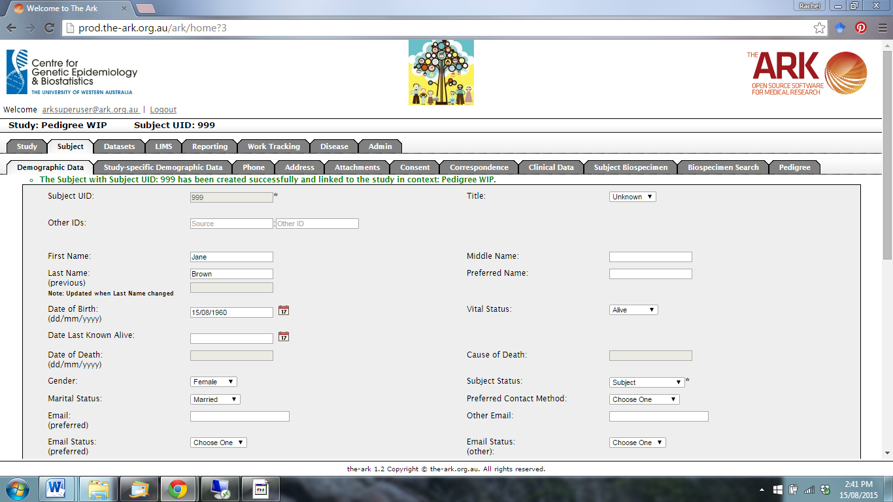

Click on the Clinical Data function.

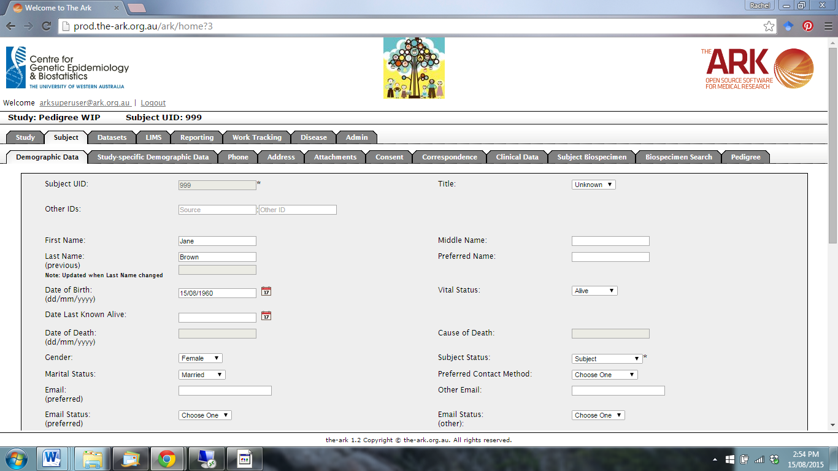

The following page will appear. Click new.

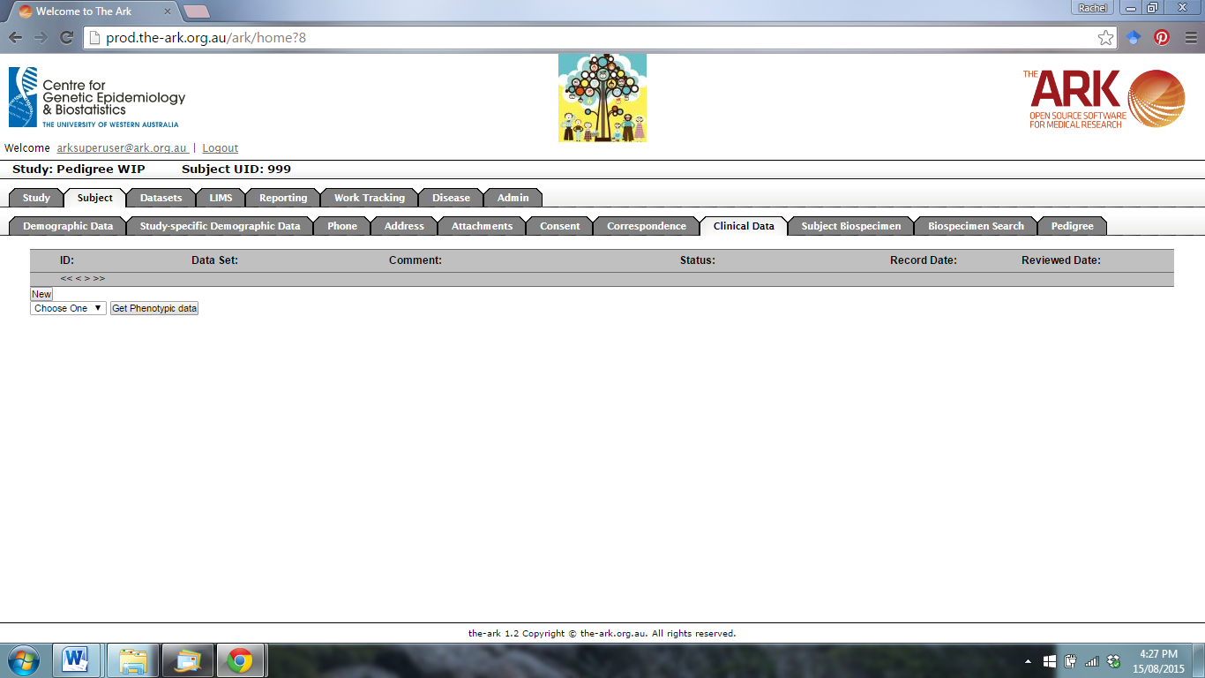

The following page will appear.

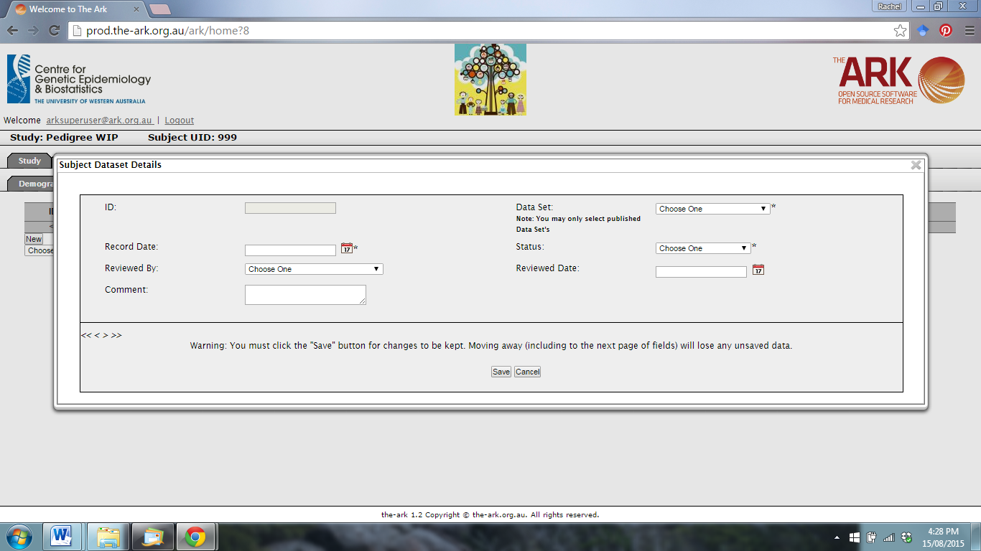

Use the drop-down menus to add clinical data information.

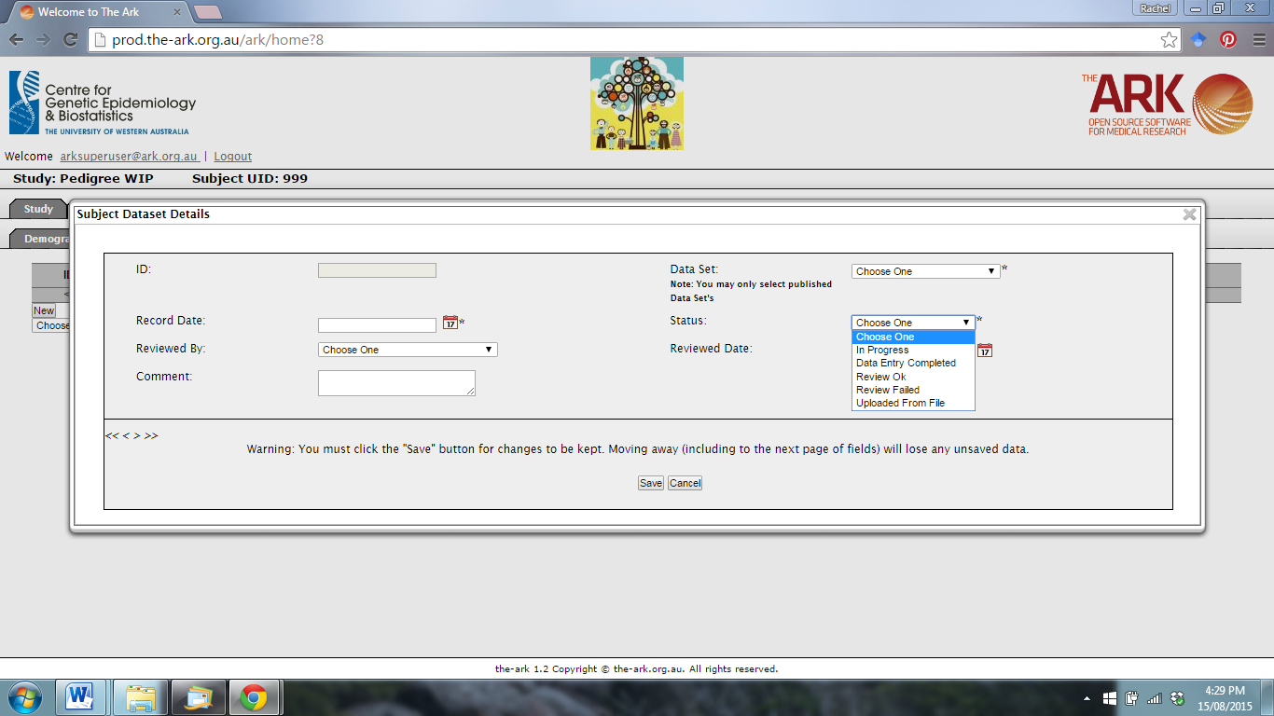

When you are finished, click Save.